# WannaCry Ransomware Attack

## Introduction

The WannaCry ransomware attack in May 2017 was one of history's largest cybercrimes, infecting over 300,000 computers across 150 countries within days. It targeted hospitals, companies, government offices, and individuals, demonstrating global digital vulnerability when security measures are neglected.

The ransomware locked files and demanded Bitcoin payment, threatening to double the ransom or permanently delete files after deadlines. This attack highlighted the critical importance of cybersecurity and showed how leaked government cyber tools can cause widespread destruction.

## The Attack

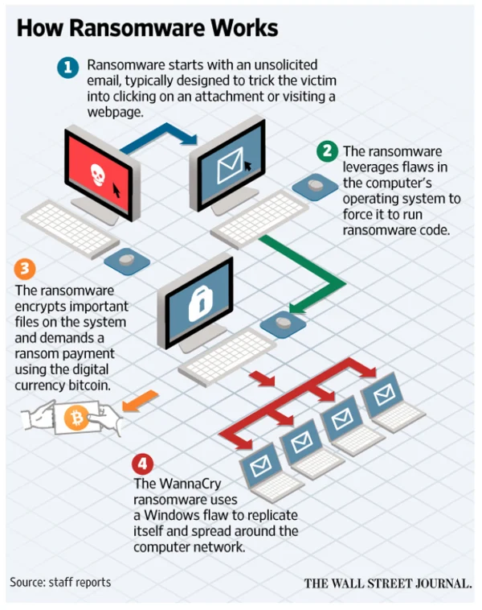WannaCry exploited a Microsoft Windows vulnerability using EternalBlue, a hacking tool originally created by the U.S. NSA and later leaked by the Shadow Brokers hacker group. The malware spread automatically through networks via the Server Message Block (SMB) protocol, making it a self-propagating worm.

Infected computers displayed a red ransom screen demanding approximately $300 in Bitcoin, with threats of price increases and file deletion. The attack spread so rapidly that hospitals, airports, banks, and offices worldwide reported system failures within hours.

## Impact

WannaCry's global impact was unprecedented:

* 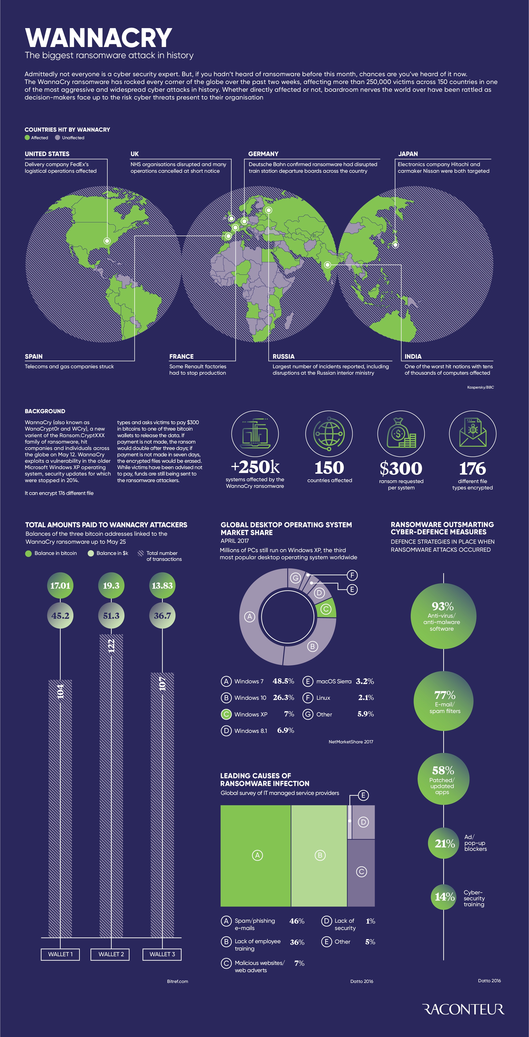**UK's NHS**: Hundreds of hospitals affected, with diverted ambulances and postponed surgeries putting lives at risk
* **FedEx**: Massive delivery delays costing millions and damaging reputation
* **Telefonica**: Network shutdowns to prevent further spread
* **Government agencies and universities**: Service delays and data loss

Financial damages exceeded $4 billion worldwide. Beyond economic impact, the attack created public safety risks, particularly in healthcare, forcing governments to prioritize cybersecurity as a national security issue.

## Forensic Investigation Challenges

The WannaCry investigation faced multiple obstacles:

1. **Attribution Difficulty**: Bitcoin payments and identity-hiding techniques made tracking cybercriminals extremely difficult
2. **Global Scale**: Coordinating investigations across 150+ countries slowed the process significantly
3. **Sophisticated Exploit**: Understanding the advanced EternalBlue exploit required extensive analysis
4. **Kill Switch Complication**: An accidentally discovered kill switch helped contain the attack but complicated forensic reconstruction
5. 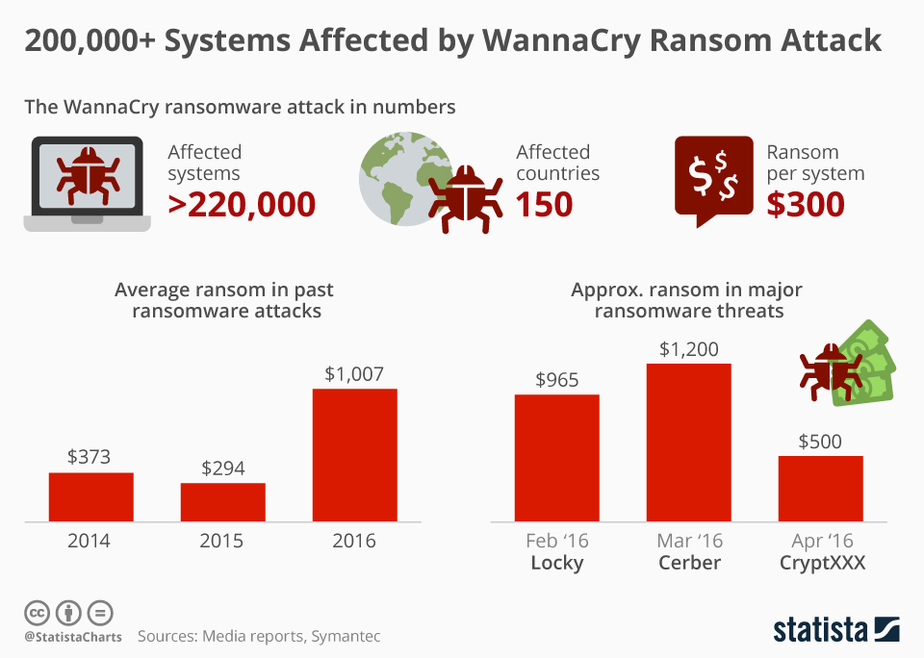**False Leads**: Initial theories about perpetrators delayed identification until experts eventually linked the attack to North Korea's Lazarus Group

These challenges demonstrated that cybercrime investigations are far more complex than traditional crimes, with criminals operating across borders and causing global damage within hours.

## Conclusion

WannaCry served as a global wake-up call, proving that outdated systems and poor cybersecurity practices can have catastrophic consequences. Organizations without Microsoft's security patches were hit hardest.

The attack raised important questions about intelligence agency responsibility when cyber tools like EternalBlue are leaked and weaponized. It sparked worldwide debates about whether agencies should keep such tools secret or disclose vulnerabilities for patching.

WannaCry ultimately proved cybersecurity is not optional but fundamental for all organizations and individuals. It remains a key case study in cyber forensics, demonstrating how a single leaked exploit can disrupt the entire digital world.

